# 2D Games Lab Sheet Week 6

Accept the GitHub Assignment from this link <https://classroom.github.com/a/GcEW8lti> (copy the link and paste it into the browser)

1. Edit the App.config. Change the setting to your student Id and Name
2. 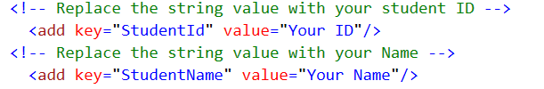
3. Add the Camera class provided to an existing
4. Add the Background content provided.
5. Import the Sprite Class from last week
6. Create a World co-ordinate for the Camera of 3000,3000
7. Create five Collectable objects as simple sprites in the world space with a randomised (use the Random .NET object) Vector 2 between 0,0 plus the width and height of the Sprite the width and height and 3000,3000 minus the width and height of the Sprite the width and height
8. Import the Animated class and create an animated player character and position the character in the middle of the Viewport.
9. Move the Camera as the player moves and collect all the Collectables with a sound effect playing as you collect them.
10. Display the position of the player above his position
11. Display a list on the screen of the active collectables and their positions in the world.